Aylmer Minor Hockey Association
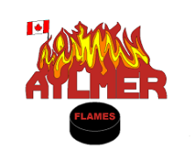
OFFENCE DECLARATION
(for use by VOLUNTEERS for whom
The Board has previously collected
A Criminal Background Check)

Name
Address
Telephone

I DECLARE, since the last Criminal Background Check collected by this Board, or since the last Offence Declaration given by me to this Board, that

[ ] I have no convictions under the Criminal Code of Canada up to and including the date of this declaration for which a pardon has not been issued or granted under the Criminal Records Act (Canada).
OR
[ ] I have the following convictions for offences under the Criminal Code of Canada for which a pardon under the Criminal Records Act (Canada) has not been issued or granted.
LIST OF OFFENCES
1 a. | Date:
b. | Court Location:
c. | Conviction:
2 a. | Date:
b. | Court Location:
c. | Conviction:

________________________________ __________________________
Signature of Volunteer Date

________________________________ __________________________
Signature of Witness Date

________________________________ __________________________
Signature of AMHA Executive Date

(To be retained on file at the arena)

